

**Green University of Bangladesh**

**Department of Computer Science and Engineering (CSE)**

**Faculty of Sciences and Engineering**

**Semester: (Fall, Year:2024), B.Sc. in CSE (Day)**

**Lab Report NO #01**

**Course Title: Web Programming Lab**

**Course Code: CSE-302 Section: 221 D13**

**Lab Experiment Name: Creating and Displaying HTML Pages Using Basic HTML Tags.**

**Student Details**

| **Name** | | **ID** |
| --- | --- | --- |
| **1.** | Tanvir Ahmed | 221002461 |

**Lab Date : 4/9/2024**

**Submission Date : 11/9/2024**

**Course Teacher’s Name : Kazi Hasnayeen Emad**

| **Lab Report Status**  **Marks: ………………………………… Signature:.....................**  **Comments:.............................................. Date:..............................** |
| --- |

**1. TITLE OF THE LAB REPORT EXPERIMENT**

Creating and Displaying HTML Pages Using HTML Tags.

**2. OBJECTIVES/AIM**

* Understanding Basic HTML Structure
* Title Tag Usage
* Exploring Different Heading Tags
* Creating and Formatting Text with Paragraphs
* Adding Horizontal Lines
* Utilizing Line Breaks
* Working with Hyperlinks

**3. PROCEDURE / ANALYSIS / DESIGN**

**Pseudocode:**

* Create an HTML document named "LabTask1.html".
* Inside the head tag, Set the title of the page as "Basic HTML Tags".
* Inside the body tag, Add different heading tags (h1 to h6) with sample text.
* Add a paragraph using the p tag.
* Insert a horizontal line using the hr tag to separate sections.
* Add a line break using the br tag.
* Create a hyperlink to the "Green University of Bangladesh" website using the tag with the appropriate href attribute.
* Add another hyperlink that points to an email address.
* Also implement bold, italic, sub-script, super-script, emphasized, and strike tags.

**4. IMPLEMENTATION**

HTML Code:

<**html** lang="en">

<**head**>

<**meta** charset="UTF-8">

<**meta** name="viewport" content="width=device-width, initial-scale=1.0">

<**title**>Basic HTML Tags</**title**>

</**head**>

<**body**>

<!-- Heading Tags -->

<**h1**>This is Heading 1</**h1**>

<**h2**>This is Heading 2</**h2**>

<**h3**>This is Heading 3</**h3**>

<**h4**>This is Heading 4</**h4**>

<**h5**>This is Heading 5</**h5**>

<**h6**>This is Heading 6</**h6**>

<!-- Paragraph and line bread tag -->

<**p**>The <**p**> HTML element represents a paragraph. (Line Breaked Here) <**br**> Paragraphs are usually represented in visual media as blocks of text separated from adjacent blocks by blank lines and/or first-line indentation, (Another Line Breaked Here) <**br**> but HTML paragraphs can be any structural grouping of related content, such as images or form fields.</**p**>

<!-- Horizontal line tag -->

<**hr** width="100%;" color="red" size="10">

<!-- Hyperlink -->

<**h2**>My University name is <**a** href="https://www.green.edu.bd/">Green University of Bangladesh</**a**></**h2**>

<!-- Email using the mailto feature -->

<**h2**>Email me to <**a** href="mailto: tanvirahmed17341@gmail.com">Tanvir Ahmed</**a**></**h2**>

<**p**>Here is the <**b**>Bold</**b**></**p**>

<**p**>Here is the <**i**>Italic</**i**></**p**>

<**p**>Here is the <**sub**>Subscript</**sub**></**p**>

<**p**>Here is the <**sup**>Superscript</**sup**></**p**>

<**p**>Here is the <**em**>Emphasized</**em**></**p**>

<**p**>Here is the <**strike**>Strike</**strike**></**p**>

</**body**>

</**html**>

**5. TEST RESULT / OUTPUT**

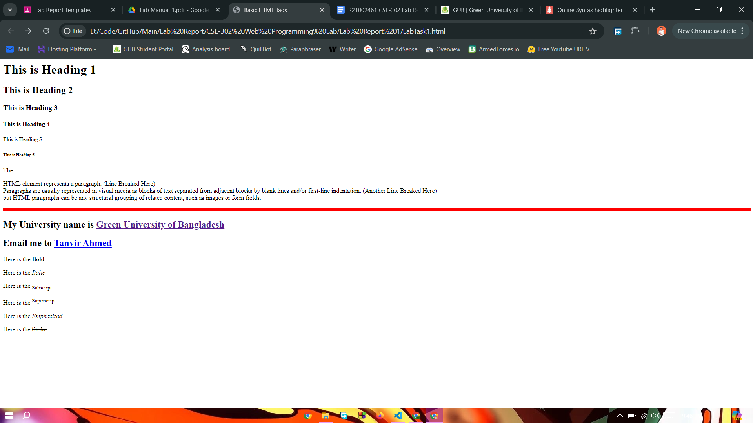

**6. ANALYSIS AND DISCUSSION**

I have already implemented most of the tags in the lab class. I learned basic syntaxes and tags from the class like, html tag, head, body, etc and today I just implemented them, The First part of the task was implemented smoothly by me but in the email part, I tried to implement using only a tag with href. It didn’t work. Then I learned about the mailto feature and implemented it in my assignment. The rest of the part was easy since I already practiced these in the lab class.